1. | Find the median.  24, 27, 35, 39, 30
 | A) 39 B) 24 C) 27 D) 30

2. | Which property of the real numbers is illustrated by the following statement?  2 · (20 + 17) = 2 · 20 + 2 · 17
 | A) | Associative property of addition | C) | Commutative property of multiplication
 | B) | Distributive property | D) | Associative property of multiplication

3. | Use the distributive property to remove the parentheses in the following expression. Then simplify your result if possible.  3(6 + 7)
 | A) 16 B) 39 C) 126 D) 25

4. | Evaluate if m = –2, n = 4, and p = –1.
 | A) 16 B) –24 C) 24 D) –16

5. | Which property of the real numbers is illustrated by the following statement?  7 + 8 = 8 + 7
 | A) | Distributive property | C) | Associative property of addition
 | B) | Commutative property of addition

6. | Solve for b. a = bc²
 | A) B) C) D)

7. | Translate the following statement into an algebraic equation. Let x represent the number.  6 times a number is 14 more than that number.
 | A) 6x = x + 14 B) 6x + 14 = x C) 6x = 14x D) 6 = 14x + x

8. | Solve and graph the solution set. 4x + 8 ≥ 3x + 16
 | A)
  0 | 8
 | B)
  0 | 8
 | C)
  –8 | 0
 | D)
  –8 | 0

9. | Convert 8.6 to a percent.
 | A) 860% B) 8.6% C) 0.086% D) 86%

10. | A television is marked down from $350 to $308. What is the discount rate?
 | A) 12% B) 87% C) 11% D) 13%

11. | Of 25 students in a class, 19 passed. What percentage of the students passed?

12. | Which of the ordered pairs is a solution for the equation 5x – 4y = 20?
 | A) (–4, –5) B) (0, 5) C) (0, –5) D) (–4, 0)

13. | Find the slope of the line passing through the points (3, 1) and (3, –1).
 | A) 1 B) –2 C) Undefined D) 0

14. | Graph 3x + 2y = 6.
 | A) | 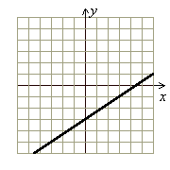
 | B) | 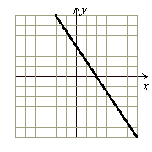
 | C) | 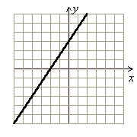
 | D) | 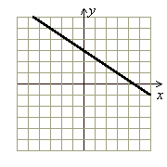

15. | The following pie chart represents the results of a survey about whether people in a certain town have cats or dogs as pets.  What percentage of the people have both cats and dogs?

16. | Give the coordinates of the points graphed below.  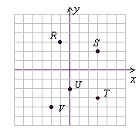
17. | Find the y-intercept.  3x – y = –15
 | A) (0, –5) B) (15, 0) C) (–5, 0) D) (0, 15)

18. | Graph the inequality.  x ≤ 5
19. | Find the slope of any line parallel to the line through points (18, 3) and (6, 4).

20. | Match the graph with one of the equations.  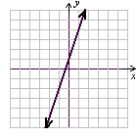
 | A) B) y = 3x + 1 C) D) y = –3x + 1

21. | Given f(x) = 5x² – 3x + 1, find f(–2).
 | A) 15 B) –25 C) 27 D) –13

22. | Write the equation of the line passing through (3, 10) and (3, –3).
 | A) y = 3 B) y = x + 3 C) y = –13x D) x = 3

23. | Solve the system by addition.  2x – 4y = 7  4x + 2y = 9

24. | Solve the following system of linear inequalities by graphing.  3x + 4y ≤ 12  x + 3y ≤ 6  x ≥ 0  y ≥ 0
 | A) | 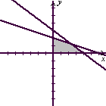 | C) | 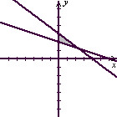
 | B) | 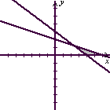 | D) | 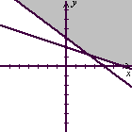

25. | Solve the following system of linear inequalities by graphing.  x + 2y ≤ 3  2x – 3y ≤ 6
 | A) | 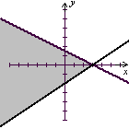 | C) | 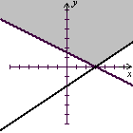
 | B) | 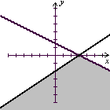 | D) | 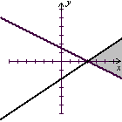

26. | One number is 12 more than another. The sum of the smaller number and twice the larger number is 39. Find the larger number.
 | A) 34 B) 17 C) 5 D) 7

27. | Bob invested $20,000, part at 14% and part at 13%. If the total interest at the end of the year is $2,720, how much did he invest at 14%?
 | A) $11,000 B) $12,000 C) $8,000 D) $13,000

28. | An employee who produces x units per hour earns an hourly wage of y = 0.55x + 7 (in dollars). Find the hourly wage for an employee who produces 13 units per hour.
 | A) $13.85 B) $14.55 C) $14.65 D) $14.15

29. | Find the slope of the graphed line.  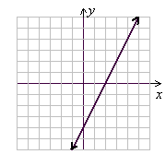
 | A) B) – C) –2 D) 2

30. | Give the coordinates of the point graphed below.  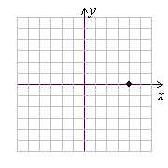
 | A) (–4, 0) B) (0, 4) C) (4, 0) D) (0, –4)

31. | Find the slope of the line passing through the points (3, 4) and (3, –4).
 | A) 1 B) –8 C) Undefined D) 0

32. | Find the slope of the line passing through the points (11, 20) and (8, 2).

33. | Find the median.  24, 28, 23, 39, 10, 48, 34

34. | Write the following phrase using symbols. Use the variable x to represent the number.  Eight less than three times a number
 | A) 3(x – 8) B) 8 – 3x C) 3(8 – x) D) 3x – 8

35. | Divide.
 | A) 5p⁹q³ B) 40p⁸q³ C) 40p⁹q³ D) 5p⁸q³

